Facebook

Added **march 08, 2018.**

To register your application in Google Drive following next steps:

1. Use the link: <https://developers.facebook.com/>.
2. Click the button “Log In”.

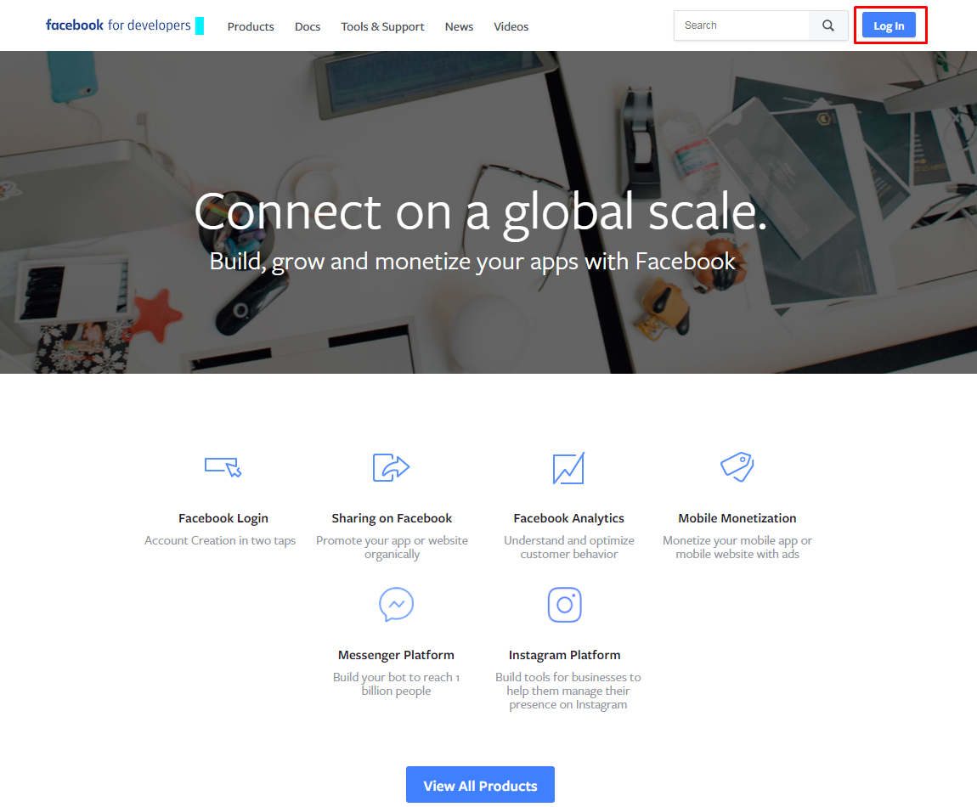

1. Log in to Facebook.
2. Click the button “Add a New App”.

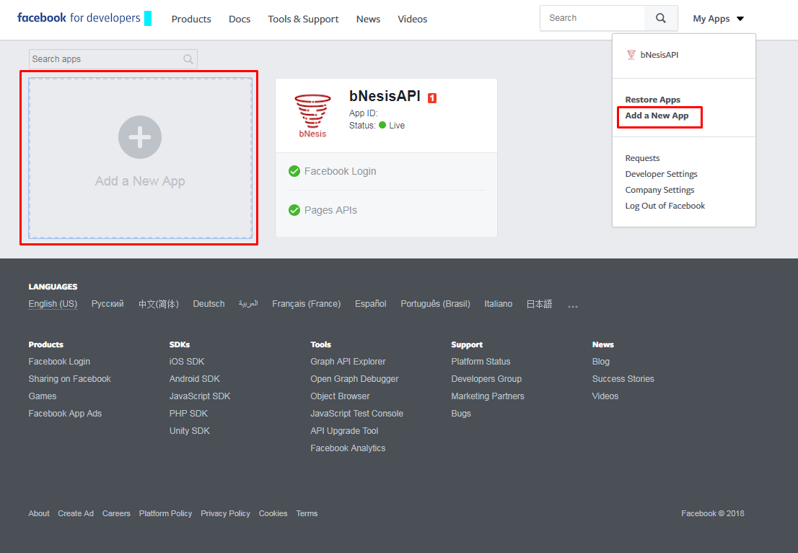

1. Fill all necessary fields in the Window “Create a New App ID”.

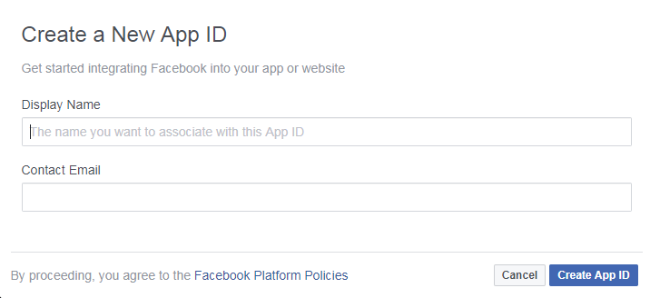

1. Click the button Create App ID.
2. In Settings of Facebook Login fill Valid OAuth Redirect URLs.

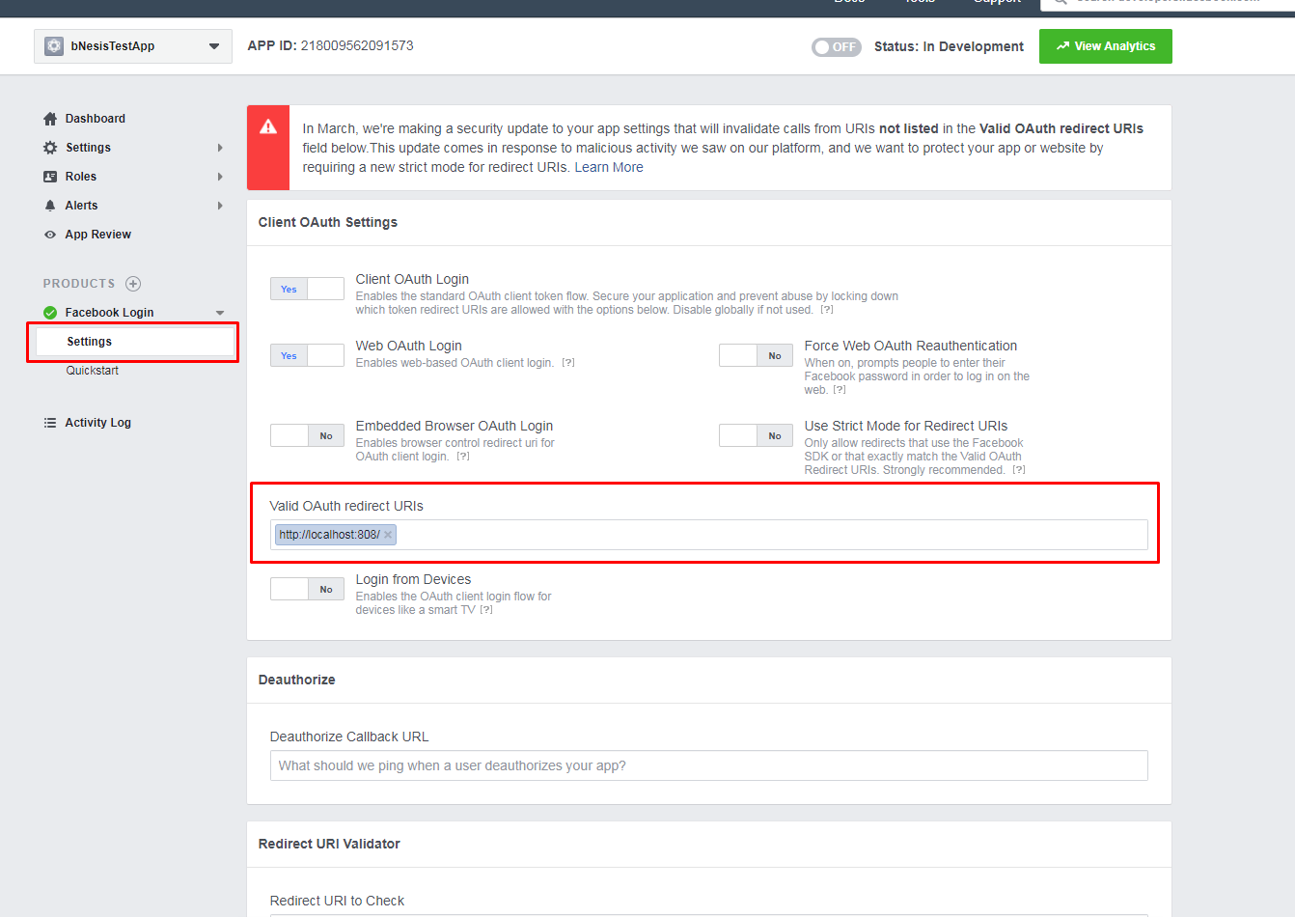

1. In Basic Settings take App ID and App Secret for authorization in bNesis.

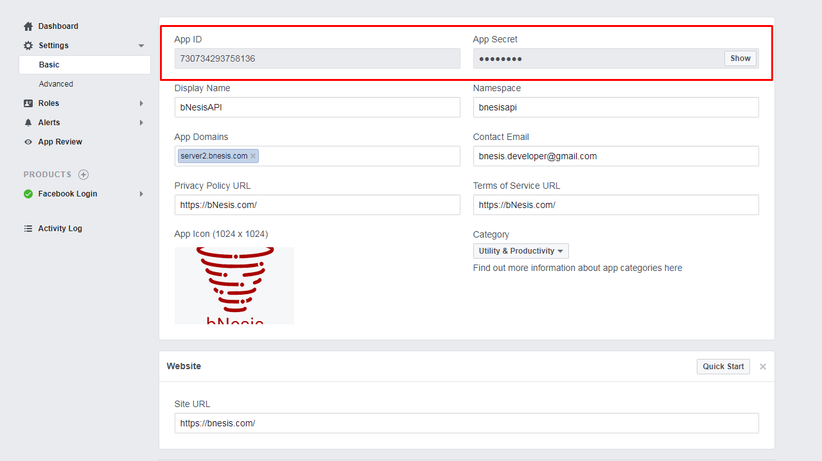

For publication app and getting permissions for calling some API you need to do following steps:

1. In settings app click button App Review:

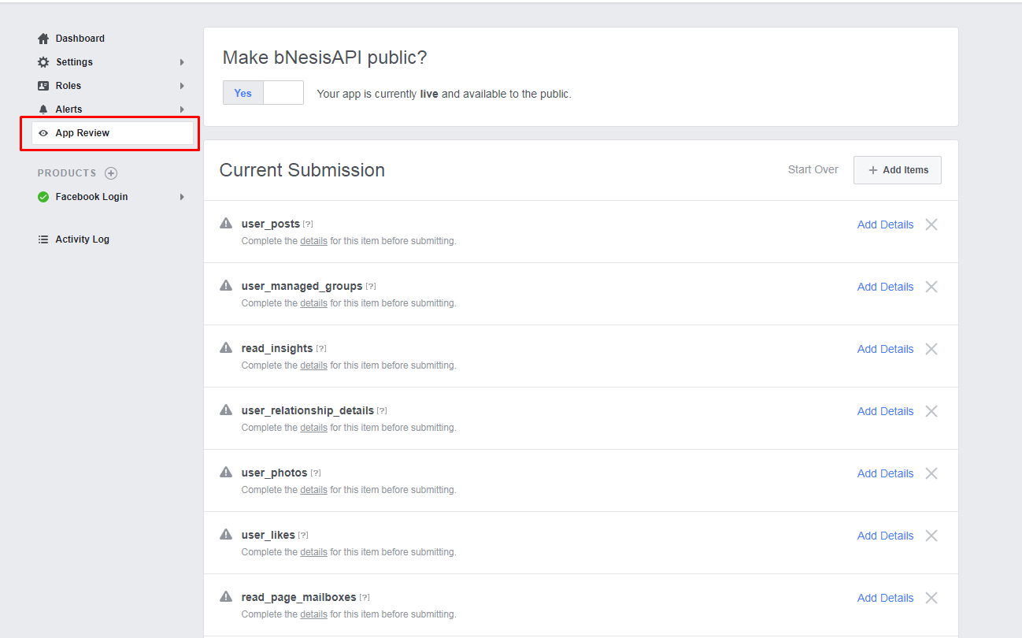

2. Click on the button “Add Items” and chose the necessary permissions following the instructions of Facebook:

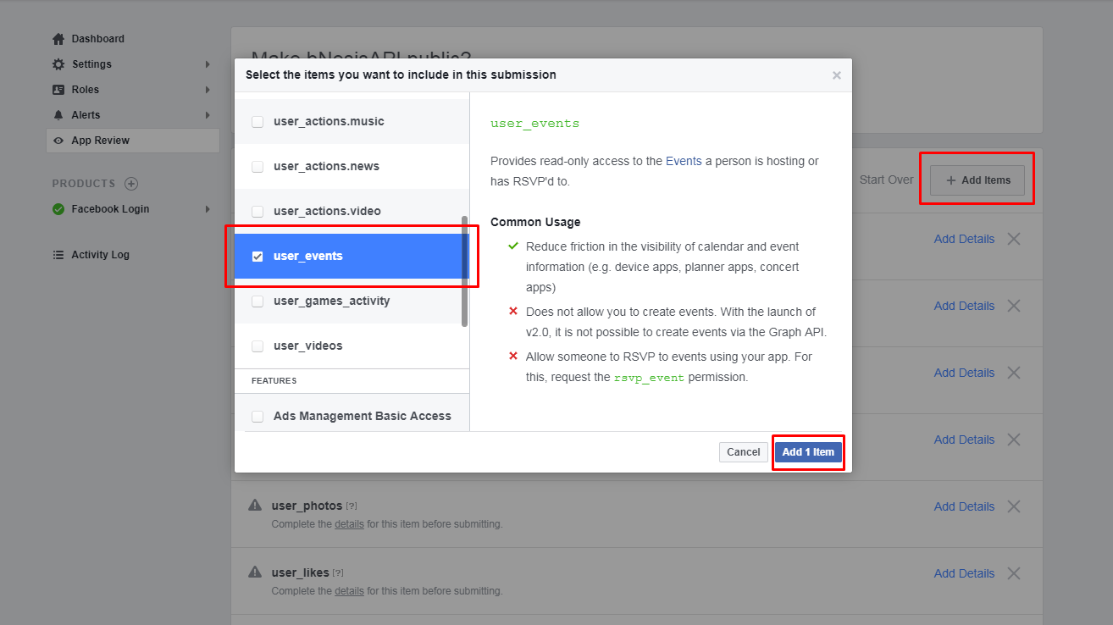

3. Next you need fill out details:

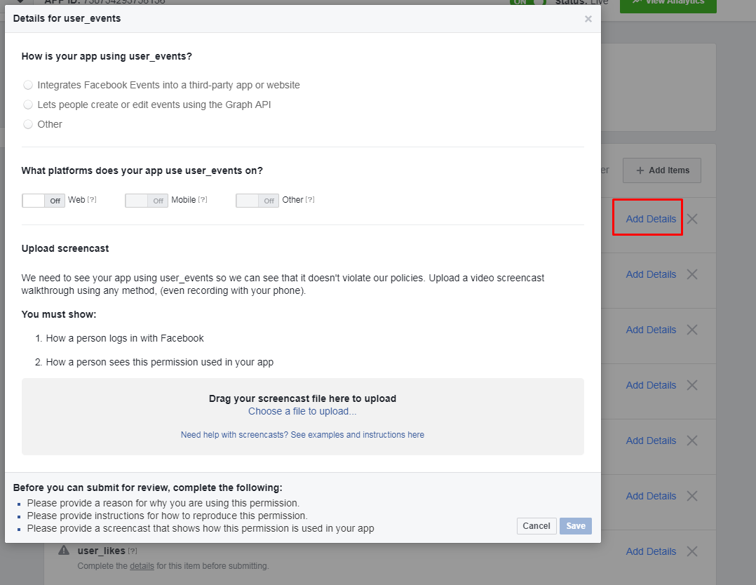

4. Then wait for approval of Facebook.

5. For publication App you need click on checkbox “Make bNesisAPI public?”

